**Simple Calculator**

**Create Simple Calculator**

This calculator program in C helps the user to enter the Operator (+, -, *, or /) and two values. Using those two values and operand, it will perform Arithmetic Operations. For this C calculator program example, we used the Switch case to check which operand is inserted by the user. Next, based on the Operand result will display. It is the same C program that we used in the first example. But this time, we are performing the arithmetic operation directly inside the Switch case blocks.

**Different ways to create a Calculator Program in C**

Following are the different ways to write a Calculator Program in the C language.

1. Calculator Program in C using the switch statement.
2. Calculator Program in C using if else if statement.
3. Calculator Program in C using do-while loop and switch statement.
4. Calculator Program in C using function and switch statement.

**Swot Analysis**

**STRENGTHS**

The strength to calculate the any numbers with different arithmetic functions.

**WEAKNESSES**

Do not include any other signs rather than this arithmetic functions (+,-,*,/,%).

**OPPORTUNITIES**

Using the physical operators this project is huge valuable in market.

**THREATS**

The slower growth in technological innovation will also bring a significant threat in the upcoming dynamic world.

**HIGH LEVEL REQUIREMENTS:-**

1 User should able to view operation list.

2 User should able to select the operation.

3 The system should able perform the given operation.

1. The system should provide correct result.

**LOW LEVEL REQUIREMENTS:-**

User should identify correctly.

**Structure**

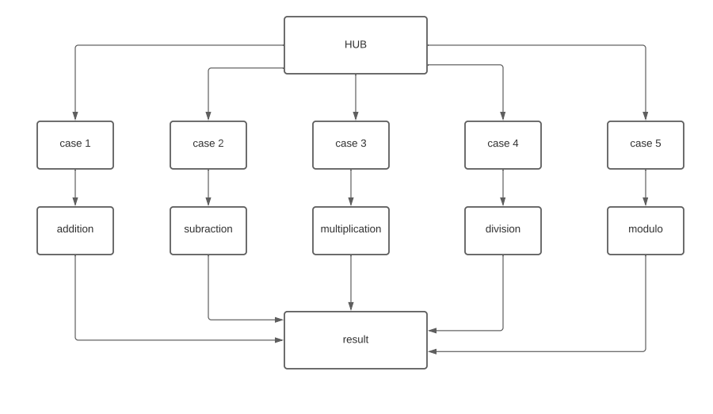

**Flow chart**

